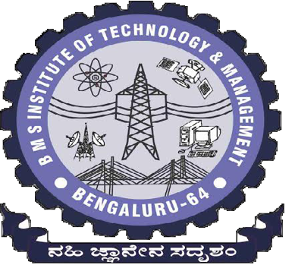**BMS INSTITUTE OF TECHNOLOGY & MANAGEMENT BANGALORE-560064**

**Department of Computer Science & Engineering**

**PBL Report of PYTHON APPLICATION PROGRAMMING 2017-2018**

**(6th Semester)**

|  |  |  |  |  |
| --- | --- | --- | --- | --- |
| **Batch No:**  CSE A - 5 | | **Guide Name:**  Mrs. Mari Kirthima A | | **Submission Date:**  25-05-2018 |
| **Project Title**  **ANAGRAMS USING PYTHON PROGRAMMING** | | | | |
| **Sl No** | **USN** | | **Name** | |
| 1 | 1BY15CS005 | | Abhishek B | |
| 2 | 1BY15CS051 | | Mohammed Daaniyaal | |

**Signature of Guide**